Requesting Access to Academic Profile – Proxy Roles

Faculty and Academic Staff (FAS) are automatically added to the Academic Profile (AP) system based on their HR appointment.

Access for administrators, proxies, and others is requested using one of two eARMs located at TeamDynamix. You will be prompted to sign in with your MSU NetID and password.

1. Select “Academic Profile – Proxy” role from the Access type list and click Request.
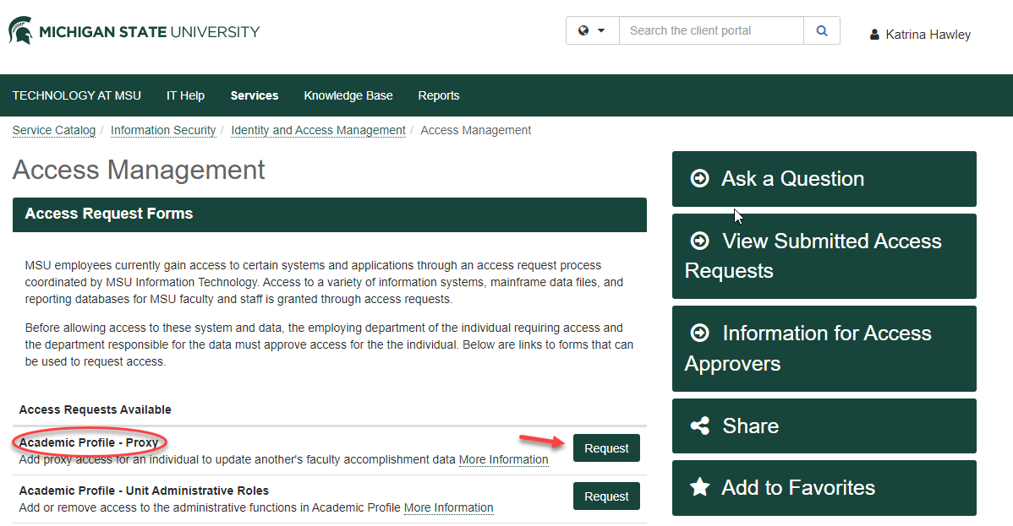
2. Select “Add” from dropdown box. Then enter FIRST NAME and LAST NAME into search field and click on “Search”. A dropdown box will appear. Use the down arrow to choose the faculty member.
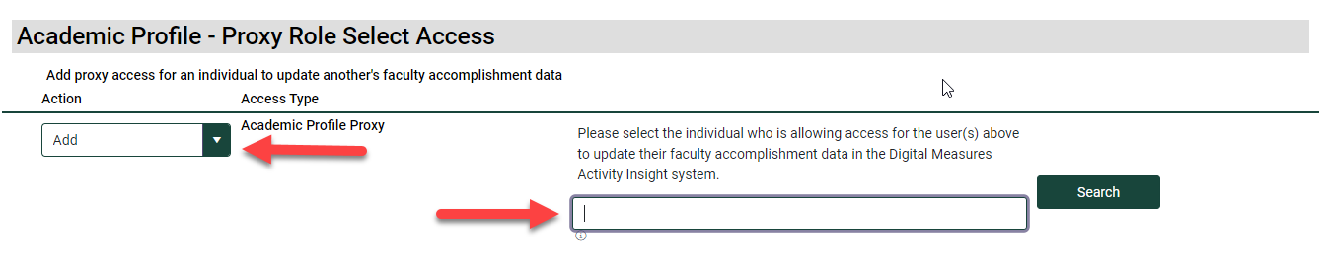
4. This section asks the user to verify whether they have completed FERPA training and have read the Institutional Data Policy and signed the related acknowledgement form. These two items are required to be granted access to AP.
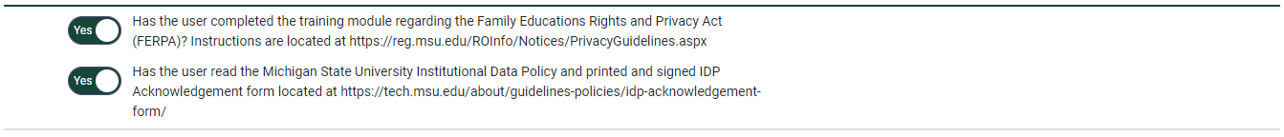
5. This comment box is optional. The last two steps are to 1) Click the Check Form box to ensure the form has been successfully completed. 2) Click on the Submit Access Request box.
